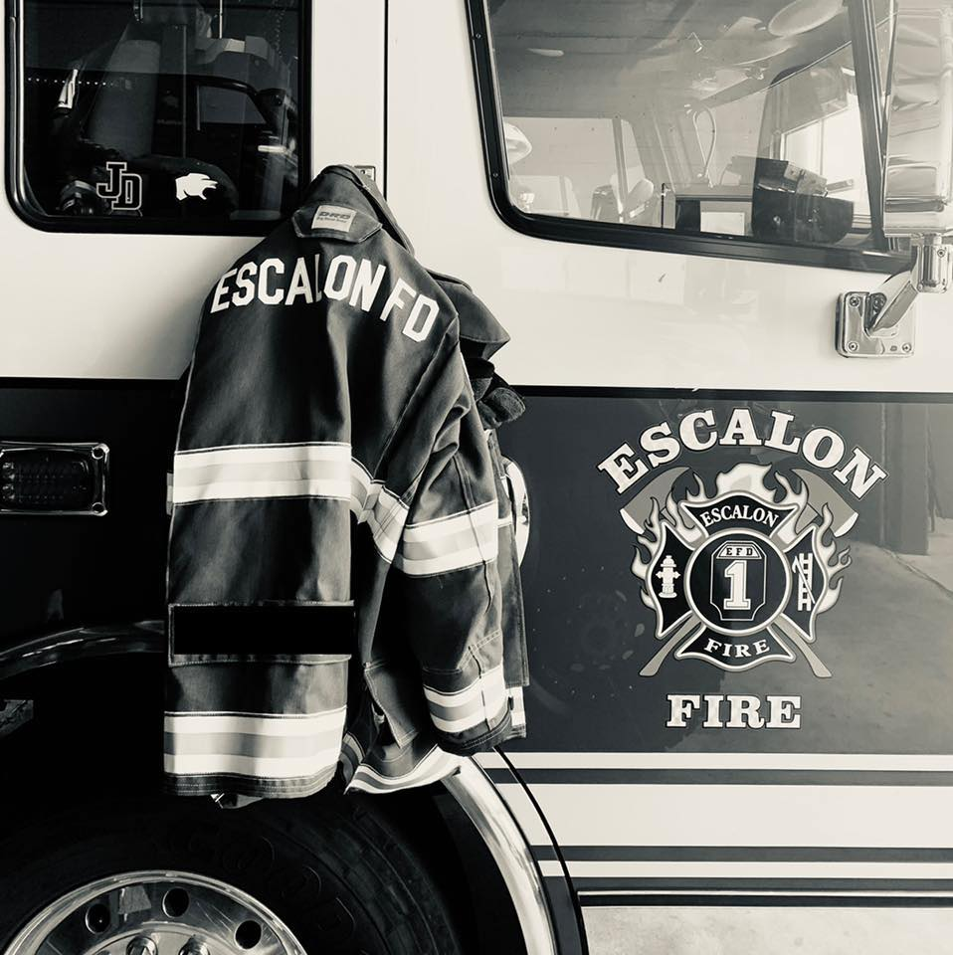

Final Budget
Fiscal Year
2026-2027

Account 600100 Salaries $ 675,000.00
Career Personnel
Reserve and Volunteer Personnel
Administrative Personnel
Seasonal Personnel
FLSA

Account 601080 Retirement $ 82,000.00

Career Personnel (13.5%)

Account 600110 Cafeteria Plan Medical $ 9,600.00

Health Care Buyout Option for Career Personnel

Account 600300 Overtime $ 70,000.00

Overtime Expense – Career Personnel
FLSA

Account 603000 Social Security (FICA) $ 47,000.00

Social Security/FICA Expense – All Payroll (6.2%)

Account 603010 Medi-Care $ 11,000.00

Medi-Care Expense – All Payroll (1.45%)

Account 601010 Unemployment Comp EDD $ 12,000.00

Unemployment Compensation Reserve Fund

Account 605000 Health Insurance $ 160,000.00

Group Medical Insurance Plan – Cal Choice
Group Dental Insurance Plan – Premier Access
Group Vision Insurance Plan – Sun Life Financial
Subtotal Employee Expenses $ 1,067,000.00

Salaries – Career, Reserve, Volunteer, Administrative
Benefits – Career Personnel
Federal and State Taxes/Expenses

Account 620100 Office Expenses $ 10,000.00

Office Supplies
Postage and Mailing/Shipping Supplies
Bottled Water
Copier Lease
Subscriptions
Computer Programs

Account 620600 Communications $ 45,000.00

Phones (Land Lines) Station 1 and Station 2
Cellular Phones and Wireless Service
Joint Radio Users Group Fees
Paging Services (“Emergency Dispatch”)
Radio Maintenance

Account 620900 Memberships $ 2,200.00

California Employers Association (CEA)
San Joaquin County Fire Chiefs Association
Other Miscellaneous

Account 621100 Maintenance $ 35,000.00

Apparatus
Equipment
Tires
Supplies

Account 62110004 Fuel $ 20,000.00

Fuel (Gasoline/Diesel)
Oil
Lubricants

Account 621700 Training and Transportation $ 15,000.00

Training Courses
Training/Career Development/Education Incentive
Training Equipment and Supplies

Account 622000 Professional Services $ 32,000.00

IT Services
Professional Expenses
Annual Audit(s)
Target Safety
Lexipol

Account 6220001 Special Accounting Reports $ 2,000.00

County Entity Fund Report
Miscellaneous Reports

Account 62200095 Auditor Direct Assessment $ 0.00

Former Auditor Chargers for Warrant Service
Former Auditor Chargers for Payroll Services

Account 62210102 Tax Administration Charges $ 23,000.00

Auditor Fees for Tax Collection

Account 622300 Publications and Legal Notices $ 500.00

Phone Directories
Advertisements
Account 622600 Special Departmental Expenses $ 6,000.00

Appreciation Dinner
Awards and Recognition
Other Miscellaneous Expenses

Account 62260104 Fire Prevention $ 4,500.00

Fire Prevention Materials for School Programs
Public Education Supplies

Account 623800 Miscellaneous Expenses $ 2,000.00

Miscellaneous Expense

Account 624000 Firefighter Safety Gear $ 20,000.00

Personal Protective Equipment (PPE) – Structure and Wildland

Account 624600 Department Expense (Household) $ 30,000.00

Wellness Physicals
Entry Physicals
Pulmonary Function Tests
TB Tests
Vaccines
General Household Supplies
Uniform Allowance – Career Staff
Flowers and Gifts

Account 624900 Utilities $ 18,000.00

P G & E Station1 and Station 2
Garbage Pick-up (Dumpster)
Sewer and Water – City of Escalon
Cable Television

Account 626000 Maintenance Structures and Grounds $ 8,000.00

Cleaning Supplies
Maintenance Supplies
Facility Upgrades
Structural Maintenance and Repairs
Maintenance of Station Grounds

Account 626900 Small Tools and Equipment $ 7,000.00

Shop Tools
Equipment Upgrades
New Equipment

Account 62320001 Workers Compensation Insurance $ 109,000.00

Fire Risk Management Services (FRMS) – Career, Reserve, Volunteer and Administrative Personnel

Account 623600 Insurance Casualty $ 32,000.00

Volunteer Fireman’s Insurance Services (VFIS) – Liability, Casualty, Apparatus and Equipment

Account 638100 Taxes and Assessments $ 1,000.00

San Joaquin Mosquito and Vector Control
San Joaquin County Flood Survey
Miscellaneous Taxes and Assessment

Account 63310001 Interest on Bonds $ 0.00

Miscellaneous Interest/Bonds

Account 641100 Structure Improvements $ 7,000.00

Repairs, Upgrades and Improvements Structures and Grounds Station 1 and Station 2

Account 645100 New Equipment $ 9,000.00

New Equipment Purchases
Equipment Upgrades

Sub Total All Accounts $ 1,484,800.00

Account 670100 Contingencies $ 70,000.00

Total Budget All Accounts $ 1,573,800.00

Capital Plan

2026-2027

Engine Lease Payment $ 35,427.00

Annual Lease Payment – Rosenbauer

Upgrades/Repairs to 1994 Pierce $ 25,000.00

Computers and Office Upgrades $ 15,000.00

Cal Fire Volunteer Fire Capacity Funding (If Awarded) $ 6,000.00

50% Funding for PPE

Total Capital Expenditures $ 81,427.00

